Bridging Healthcare Gaps: AI-Powered Health Connect Kiosks for Rural India

1. Dr. K. Little Flower
dept. of Computer Science & Engineering
St. Peter’s Engineering College
Jawaharlal Nehru Technological University
Hyderabad, India
klittleflower@stpetershyd.com

4. Vanjarapu Bhanu Charan
dept. of Information Technology
St. Peter’s Engineering College
Jawaharlal Nehru Technological University
Hyderabad, India
vanjarapu.bhanucharan0123@gmail.com

2. Punna Sai Ganesh
dept. of Information Technology
St. Peter’s Engineering College
Jawaharlal Nehru Technological University
Hyderabad, India
punnasaiganesh111@gmail.com

3. Bellamkonda Raghu
dept. of Information Technology
St. Peter’s Engineering College
Jawaharlal Nehru Technological University
Hyderabad, India
bellamkondaraghu6@gmail.com

Abstract— Healthcare in rural India suffers from inadequate infrastructure, a scarcity of medical professionals, and late diagnosis. The paper presents an innovative solution—a kiosk based on AI-assisted telemedicine—designed to bridge the gap in healthcare for rural areas. The kiosk takes advantage of cutting-edge technologies such as artificial intelligence to provide accessible, efficient, and reliable medical services. The features are user-friendly in this system, such as the voice-to-text processing capability and disease prediction through a preprogrammed machine learning algorithm, as well as seamless doctor-patient connectivity. Some enhancements for future development includes support for multiple languages, and improved user interfaces.
Keywords— AI-assisted telemedicine, Rural healthcare, Telemedicine kiosk, Disease prediction, Machine learning, Healthcare accessibility

Introduction
Despite these challenges, the access to quality healthcare in rural India remains scarce due to the lack of medical professionals, infrastructure, and logistics. This results in delayed diagnosis, inadequate treatment, and poor health outcomes for these underserved communities. Telemedicine is a promising approach to addressing such challenges by providing remote consultations and diagnostics. However, there is little scope in a rural setting because of a couple of factors related to costs, customization limitations, and technological constraints. Accordingly, this paper has proposed an AI-assisted telemedicine kiosk for overcoming these limitations and delivering accessible, efficient, and reliable health services to the rural population. Bridging the gap of the patient to the healthcare providers through the employment of advanced technology, including AI the kiosk will comprise the following as features: real-time consultation with the doctor, the AI-driven system that predicts a disease, and connecting it to the local workers to deliver on time medicines along with follow-ups. This new system is aimed at transforming the delivery of health care in rural areas by fusing state-of-the-art technology with grassroots healthcare networks, thus making quality medical services accessible to everyone.

II. LITERATURE REVIEW
In [1] Blake (2008) discussed the use of mobile phone technology in patient care, demonstrating its accuracy in spatial representation and visual mapping. However, the reliance on GIS infrastructure posed limitations for real-time updates in rural healthcare applications.

In [2] Senbekov et al. (2020) surveyed the progress made in digital healthcare technologies, underlining the facilitation of access and data management. Nevertheless, implementation and data security challenges were identified as major drawbacks.

In [3] Ganesh et al. (2020) proposed AutoImpilo, an IoT smart health machine to improve telemedicine services. The research focused on real-time monitoring and automation but recognized high initial expenses and system integration issues as limitations.

In [4], Zadar et al. (2021) investigated the shift towards AI-supported mental health care, emphasizing patient engagement. Although AI demonstrated potential in improving mental health diagnoses, ethical implications and bias were noted as main limitations.

In [5], Sun et al. (2021) discussed telemedicine's effect on health management in the COVID-19 pandemic. They noted its efficiency in distant consultations and minimizing hospital burdens, although issues like the digital divide and privacy threats were also brought up.

III. PROPOSED SYSTEM
The AI-Assisted Telemedicine Kiosk for Rural India is a revolutionary solution intended to enhance health care accessibility in rural areas through the provision of remote medical consultation by AI and telemedicine. Access to healthcare is limited in many rural areas of India, largely due to the lack of medical professionals as well as long distances that have to be covered in traveling to the urban healthcare centre. It is a self-service, user-friendly kiosk, which uses a touch screen that leads patients to enter their symptoms and personal details. Then AI-based tools analyse the symptoms, which give some preliminary diagnostic suggestions for the professional medical practitioner to assess through video consultation.
The kiosk will be fitted with all necessary medical equipment such as thermometers, blood pressure monitors, pulse oximeters, and stethoscopes to collect all health data directly transmitted to the health provider. It ensures doctors can access the data in real-time for more informative consultation. AI tools will help in the diagnosis processes where recommendations will also be posted out based on a huge medical database, and automated follow-up reminders will help patient adherence to treatment plans.
The system would provide multi-language support to counter the linguistic diversity of rural India. This will allow patients to interact with the kiosk in their preferred language. It overcomes the linguistic barriers and renders healthcare services to a greater section of the people. Moreover, voice input and audio instructions can be used to facilitate access for those with disabilities as well, hence increasing the number of users for the system.
The telemedicine kiosk is solar-powered so that it could function in cases where electricity cannot be relied on. It shall be connected to a central health network so as to store all patient data privately and to offer continuity of care through the facility of tracking past medical histories and follow-up appointments. Further features may include added diagnostic tools, integration with mobile platforms, noise cancelling for the sake of voice clarity in video calls, and periodic updates for AI models on new medical innovations.
The AI-Assisted Telemedicine Kiosk is meant to offer low-cost and timely healthcare services to rural populations, thereby reducing long travel and the problems of scarce healthcare infrastructure. Using AI, telemedicine, and local medical devices, the system will improve the health outcomes of rural communities significantly and make healthcare more accessible to those who need it the most.

IV. SYSTEM DESIGN
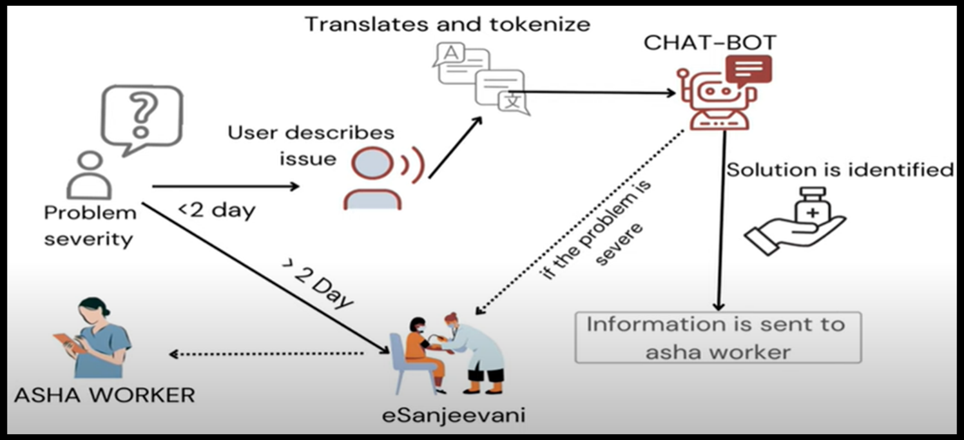
SYSTEM ARCHITECTURE
The AI-Assisted Telemedicine Kiosk for Rural India will be modular, scalable, and efficient in providing core healthcare services through telemedicine and AI-powered diagnostics. The design features are:
1. Self-Service Kiosk Interface: The system includes an interactive touchscreen interface guiding patients through the input of their symptoms, personal details, and health history. This interface has been designed for simplicity and access, with multiple languages to help accommodate the needs of rural India, as well as voice input and audio instructions to help people with disabilities.
2. AI-Based Diagnostic System: It has an AI algorithm that analyses the symptoms input by the patient. The symptoms are compared to a medical database in order to produce possible diagnoses. This preliminary diagnosis helps doctors take more informed decisions during video consultations. The AI is designed to learn continuously and improve its accuracy over time, based on real-world data and feedback from the medical profession.
3. Video Consultation Platform: The kiosk will be provided with video conferencing tools, comprising a camera and microphone, that allow for the real-time consultations with remote doctors. This video consultation platform is very useful to facilitate smooth communication between the patient and the healthcare provider. Live data is transmitted during the consultation from medical devices, such as blood pressure monitors and pulse oximeters.
4. Medical Device Integration: The kiosk contains important health devices that include thermometers, blood pressure monitors, pulse oximeters; these devices obtain vital health information from patients and send it directly to the health provider, where they can get an accurate evaluation when consulting with a patient. Such integration ensures doctors have all information needed to treat and diagnose their patients.
5. Security and Data Management: The system guarantees the secure management of patient data with high-level encryption while sending and storing the data. The patient records with medical history, diagnosis, and consultation information are stored centrally, and access is granted only to authorized health professionals. It provides privacy and satisfies healthcare rules.
The system design ensures scalability since, in future, it shall include more diagnosing tools or integrate with mobile units to access remotes and noises cancellations meant for better reception during noisy transmission.

V. RESULTS
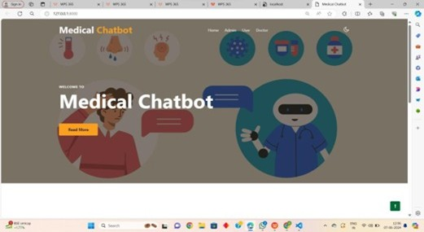
FIG 1: HOME PAGE
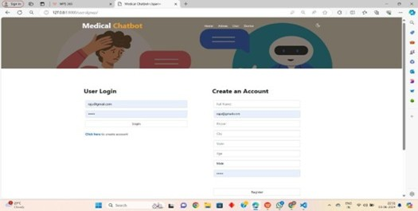
FIG 2: USER LOGIN PAGE
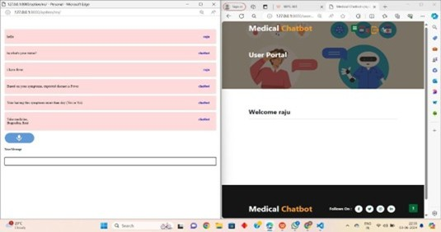
FIG 3: USER INTERACTION WITH CHATBOT
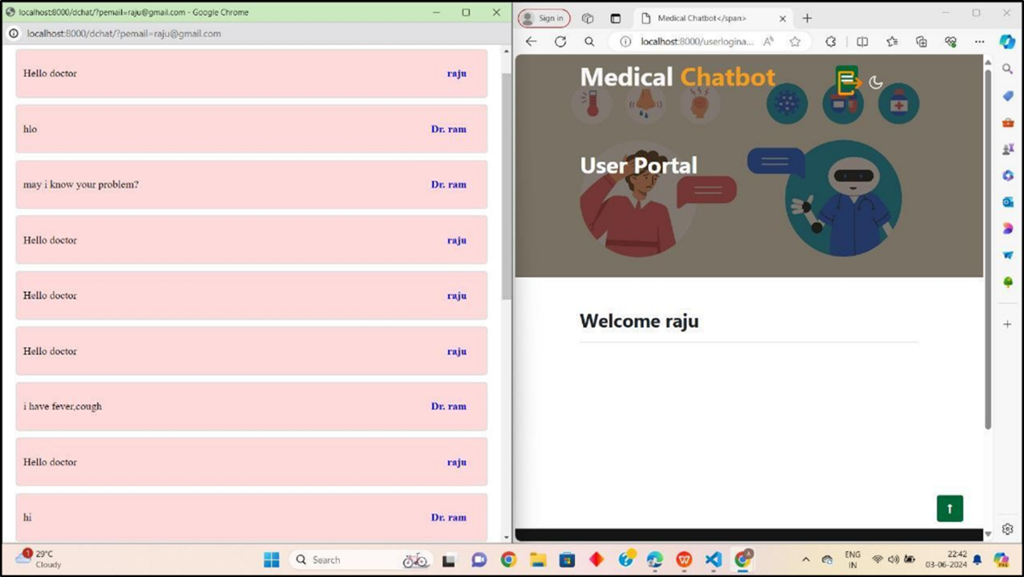
FIG 4: USER INTERACTION WITH DOCTOR
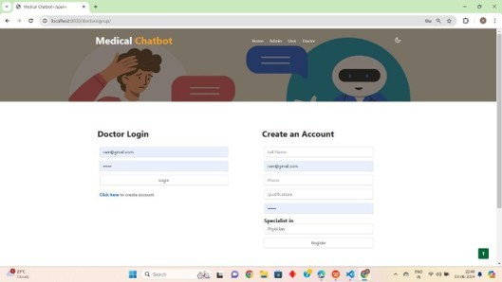
FIG 5: DOCTOR LOGIN PAGE

The AI-Assisted Telemedicine Kiosk has brought major improvements in health care accessibility and delivery in rural India. Multi-language support and user-friendly interface of the kiosk enhanced the inclusivity factor of medical services and made it more accessible to the diverse demographics and people with disabilities. Preliminary diagnostics through AI, real-time data transmission from integrated medical devices, and video consultations helped healthcare delivery become more efficient and informed. User satisfaction was high, and adherence to treatment plans improved; the solar-powered kiosks ensured reliability in areas with unstable electricity. Modular design allowed for future enhancements, such as additional diagnostic tools and mobile platform integration. The system has reduced time-to-treatment, improved chronic condition management, and increased access to quality healthcare services in underserved rural communities, with continued updates ensuring its relevance and effectiveness.

VI. CONCLUSION

In conclusion, the AI-Assisted Telemedicine Kiosk for Rural India is an innovative and efficient solution to the healthcare challenges of rural populations. Combining AI-driven diagnostics, telemedicine consultations, and medical device integration, the kiosk ensures that patients receive timely, accurate healthcare without the need for long-distance travel. The system is user-friendly, supports multiple languages, and has accessibility features that make it adaptable for use by a wide range of users, including people with disabilities. Focusing on data security and privacy, the system ensures the protection of patient information while enabling healthcare providers to offer continuous, high-quality care. The kiosk's solar-powered design and scalability ensure that it can be deployed in remote areas and can evolve with future technological advancements, providing long-term, sustainable healthcare solutions for rural India.

Acknowledgment
We extend our heartfelt gratitude to Dr. K. Little Flower for her invaluable guidance and unwavering support throughout this project. We are also thankful to the Head of the Department of Computer Science and Engineering for timely assistance, as well as, We are extremely thankful to our Principal Dr. Nagu Chandra Sekhar Reddy, who stood as an inspiration behind this project and heartfelt for her endorsement and valuable suggestions, for her inspirational leadership. We respect and thank our secretary Sri. T. V. Reddy for providing us the opportunity to undertake this project at St. Peter's Engineering College. Lastly, we express our deep thanks to our parents and friends for their moral and financial support, which was crucial in our successful completion of this work..

References
- Blake H. Innovation in practice: mobile phone technology in patient care. British journal of community nursing. 2008 Apr;13(4):160-5.
- Senbekov M, Saliev T, Bukeyeva Z, Almabayeva A, Zhanaliyeva M, Aitenova N, Toishibekov Y, Fakhradiyev I. The recent progress and applications of digital technologies in healthcare: a review. International journal of telemedicine and applications. 2020;2020(1):8830200.
- Ganesh D, Seshadri G, Sokkanarayanan S, Bose P, Rajan S, Sathiyanarayanan M. AutoImpilo: smart automated health machine using IoT to improve telemedicine and telehealth. In2020 International Conference on Smart Technologies in Computing, (ICSTCEE) 2020 Oct 9 (pp. 487-493).
- Zadar T, Morrow EM, Stockley R. Ensuring patient and public involvement in the transition to AI‐assisted mental health care: A systematic scoping review and agenda for design justice. Health Expectations. 2021 Aug;24(4):1072-124.
- Sun R, Blayney DW, Hernandez-Boussard T. Health management via telemedicine: Learning from the COVID-19 experience. Journal of the American Medical Informatics Association. 2021 Nov 1;28(11):2536-40.

